
MINISTRY OF ENERGY AND PETROLEUM
State Department for Petroleum

REPORT ON SYSTEM BENCHMARKING EXERCISE

HELD ON

18TH MARCH 2026
AT
NATIONAL OIL CORPORATION OF KENYA
HEADQUARTERS

1.0 INTRODUCTION
The development of an effective and sustainable system requires a clear understanding of existing solutions and industry best practices. To support this process, a benchmarking exercise was conducted at National Oil Corporation of Kenya.
The purpose of this exercise was to evaluate the performance, structure, and functionality of an existing system and to draw lessons that can inform the development of the Unified Petroleum Exploration and Monitoring Management Information System (UPEMMIS). This report documents the process, findings, and recommendations derived from the exercise.
1.1 Objectives of the Exercise
The key objectives of the benchmarking exercise were:
- To assess the architecture and functionality of an existing system
- To identify best practices and success factors
- To highlight gaps and challenges in current implementations
- To generate recommendations for improving system design
- To inform and strengthen the Terms of Reference
1.2 Scope
The benchmarking exercise focused on the following areas:
- Enterprise Resource Planning and Integrated Business Systems
- Petroleum Supply Chain and Deport management system
- ICT infrastructure and cybersecurity framework
- Data Governance and reporting mechanism
- Revenue management and financial system integration
- Implementation challenges, lesson learned and sustainability strategies

2.0 Participants
The exercise was conducted by a team from National Oil Corporation, Petroleum officers and State Department for Petroleum’s ICT team.
3.0 Methodology
The exercise was conducted by National Oil Corporation of Kenya ICT and NDC team, and the following methods were adopted:
- PowerPoint presentations.
- Discussions with system users, administrators, and technical staff
- Examination of system features, workflows, and interfaces
- Question-and-answer sessions
4.0 Key areas of assessment
4.1 ICT Infrastructure & Cybersecurity framework
The ICT infrastructure at National Oil Corporation of Kenya is built to support both enterprise operations and petroleum supply chain systems.
Infrastructure supports ERP, depot systems, and financial systems integration
Likely includes:
- On-premise data centers
- Network connectivity across depots and stations
Cybersecurity measures include:
- Access controls
- Security policies
- Continuous monitoring
4.2 Enterprise Resource Planning & Integrated Business Systems
NOC operates an Oracle-based ERP system (Oracle 11g & E-Business Suite 12.1.3) supporting core business operations.
- NOC ERP runs on Database version is 11g 11.2.0.2.0 and application version 12.1.3
- The modules include:
  - Alignment & Optimization of Asset & Tax Systems
  - Optimization of Cost and Inventory Systems
  - Alignment & Optimization of the Procure to pay Cycle
  - Order to Cash Cycle
  - Implementation of the Enterprise Asset Management Project
  - Oracle Cash Management
  - Implementation of Oracle Contracts for Procurement
  - Oracle Sourcing
  - Optimization of the Enterprise Infrastructure
  - Optimization of Human Resources
  - Oracle Projects and custom reports.
4.3 Petroleum Supply Chain & Depot Management System
NOC operates systems supporting: Fuel storage and depot operations, stock movement and tracking, and distribution logistics
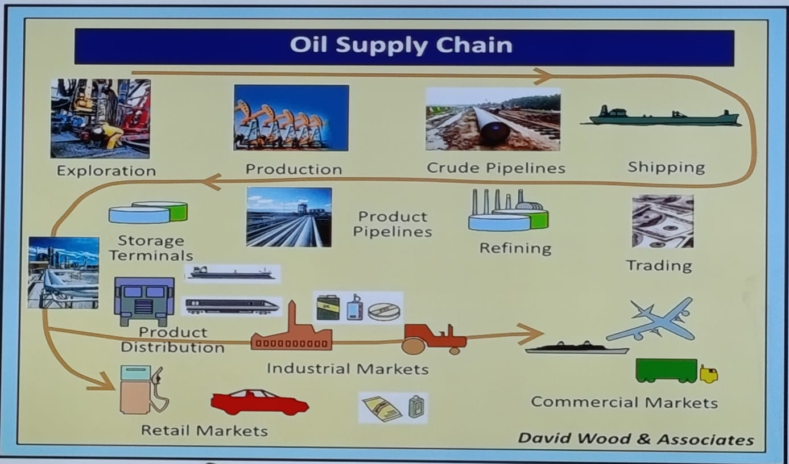
NOC enables monitoring of:
- Fuel inventory levels
- Product movement across depots
- Supports supply chain efficiency and operational visibility
4.4 Revenue Management & Financial System Integration
Revenue systems are integrated with ERP to support:
- Billing and invoicing
- Payment tracking
- Financial reporting
Thus, integration enhances:
- Financial transparency
- Accountability
- Supports core petroleum revenue streams
4.5 Data Governance & Reporting Mechanisms
NOC utilizes structured data management processes supported by ERP and reporting tools.
Data is used for:
- Operational reporting
- Financial reporting
- Systems support basic reporting capabilities
4.6 Challenges, lessons learned & sustainability
Key Challenges Identified are as follows:
- Legacy systems and outdated infrastructure
- Data security risks
- Large and inefficient backup systems
- Power outages affecting system availability
- Limited funding for ICT upgrades
- Legal and regulatory compliance pressures
These challenges indicate a mid-level digital maturity, with strong foundations but limited modernization.

5.0 Findings and Analysis
5.1 Best practices identified
- A scalable and modular system architecture in place
- Well established ICT Infrastructure
- Security controls and policies in place
- Continuous monitoring of the systems
- Cybersecurity measures in place
- Training and staff awareness done regularly

5.2 Challenges
- Data Security
- Large data Backup sets
- Legal Requirements
- External factors such as power outage
- Limited Back up
- Lack of modernized infrastructure
- Lack of funds

6.0 Lessons learnt
The benchmarking exercise revealed several important lessons:
- Systems should be designed with scalability in mind
- User involvement is critical for successful adoption
- Integration enhances system efficiency and usability
- Continuous system monitoring and updates are essential
- Training and awareness are key
- Power and network instability directly affect system performance. Infrastructure resilience must be prioritized.
- Large, unoptimized backup systems create inefficiencies. Data lifecycle management is essential.
- Increasing cyber risks require continuous improvement. Security must be proactive, not reactive.
- Limited budgets slow modernization. Strategic ICT investment planning is necessary

7.0 Recommendations
Based on the findings, the following recommendations are proposed:
- Adopt a scalable and modular system architecture
- Ensure infrastructure is up to date
- Strengthen data security measures
- Provide comprehensive user training
- Establish clear system governance structures
- Plan for comprehensive data backup and recovery, system expansion and upgrades
- Increase Investment in ICT by allocating budget for: System upgrades, Training and Infrastructure modernization
- Capacity Building through continuous training for: ICT staff and end users

8.0 Conclusion
The benchmarking exercise provided valuable insights into the design, implementation, and management of effective systems. By analyzing an existing system, key strengths and weaknesses were identified, offering practical lessons for the development of UPEMMIS.
The recommendations outlined in this report will guide the enhancement of the Terms of Reference and support the development of a robust, efficient, and sustainable system.

